SPICA-VIS
Instrument Control Software

Authors: Philippe Berio and Denis Mourard

Doc. No. : SPICA-VIS-0002

Issue: 2

Date: 10/07/2020

CHANGE RECORD
ISSUE | DATE | SECTION | COMMENTS
1 | 13/02/2020 | All | Creation PB
1.1 | 09/03/2020 | Spectro/Sources/CHARA | Blue addition DM
1.2 | 15/06/2020 | 4 and 5 | New motors added and server sections filled PB
2 | 10/07/2020 | All | Ready for Design review

Table of Contents
1. Scope 4
2. Motorized devices 4
2. Detectors 5
3. Sources 5
4. Power control 5
5. Software 6
5.1. Context 6
5.2. Devices 6
5.2.1. spica_pdc_server 6
5.2.2. spica_adc_server 6
5.2.3. spica_periscope_server 7
5.2.4. spica_ip-ctrl_server 8
5.2.5. spica_tt-tracker_server 8
5.2.6. spica_delayline_server 9
5.2.7. spica_shutter_server 10
5.2.8. spica_grating_server 11
5.3. Detectors 11
5.3.1. spica_scidet_server 11
5.3.2. spica_ipdet_server 12
5.4. Power 13
5.4.1. spica_power_server 13

Scope
The scope of this document is to describe the low-level control Software of SPICA-VIS. It presents the list of motorized devices and detectors and the way they are operated.

Motorized devices
The naming convention of the modules and the motors is presented in the product tree (see SPICA-VIS-0004).

Modules | Motors | Number | Type | Controller | Client/Server
SFO (SPICA Feeding Optics) | FOP | 1 | DC motor | VEGA controller | spica_periscope_server
SFO (SPICA Feeding Optics) | TT-n  TP-n  n∈[1,6] | 12 | Newport 8816 | Newport 8742 | spica_ip-ctrl_server
PDC (Polarization Delay Compensator) | PDC-n  n∈[2,6] | 5 | Rotation Stage with Stepper Motor | R256 – Lin Engineering | spica_pdc_server
ADC (Atmospheric Dispersion Compensator | AF-n  AS-n  n∈[1,6] | 12 | Rotation Stage with Stepper Motor | R256 – Lin Engineering | spica_adc_server
BAS (Beam Adjustment System) | PH-n  PV-n  n∈[1,6] | 12 | Newport 8814 | Newport 8742 | spica_ ip-ctrl _server
BAS (Beam Adjustment System) | FT-n  FP-n  n∈[1,6] | 6 | PI | DNA Cube | spica_tt-tracker_server
SFI (Spatial Filter Input mode) | DL-n  n∈[2,6] | 5 | Newport MFA-PP | Newport SMC100PP | spica_delayline_server
BSL (Beam Selector) | SH-n  n∈[1,6] | 6 | Thorlabs  MFF101/M |  | spica_shutter_server
BCS (Beam Control System) | BCC | 1 | Newport MFA-PP | Newport SMC100PP | spica_ipdet_server
Table 1: Motorized Devices of the injection table of SPICA-VIS

Module | Names | Number | Type | Controller | Client/Server
Grating wheel |  |  |  |  | spica_grating_server
Wavelength adjusting |  |  |  |  | spica_grating_server
Table 2: Motorized Devices of the spectrograph table of SPICA-VIS

Most of the controllers listed in Table 1 have a serial connection. We plan to operate them through the network thanks to serial device servers (Nport5610).
SPICA/VIS operations will also require communicating with different specific CHARA servers:
- STS
- LDC
- MIRCX/SPICA-FT

Detectors
SPICA-VIS uses 2 detectors:
- Science Detector: ANDOR 1024x1024. It will probably be operated with the USB interface. Some tests will be done as soon as possible in order to be sure that the Cameralink interface is not necessary.
- Pupil/Image Control Detector: ANDOR IXON 897 512x512. During observations, it will be operated up to 200Hz in order to optimize the flux injected into the single mode optical fibers. This frequency cannot be achieved with the standard USB interface. It is necessary to use the Cameralink interface. The data from the detector are transferred to the computer via a dedicated Cameralink frame grabber (Bitflow Neon – aleady tested on CESAR experiment).

Sources
SPICA-VIS will use two main sources:
- retrofeed: white light source for retro-feeding the single mode fibers and for the recording of the reference positions on the Image and Pupil Control Detectors.
- spectral lamp: We plan to use one or two wavelength calibration light sources (https://www.oceaninsight.com/products/light-sources/calibration-sources/wavelength-calibration-sources/) connected through multimode fibers to the V-groove.

Power control
SPICA-VIS devices will be connected to remotely controlled plugs. The list is presented below.

Software

Context
The device and camera control software should be implemented as CHARA client/server applications. A low level (or engineering) GUI should be developed for each client/server application. Each SPICA-VIS server will be registered to CHARA sockman.

Devices

spica_pdc_server
This server accepts 15 commands (3 commands for 5 beams, the crystal plate is fixed for beam 1):
- HOME: go back to the home position of the rotation stage
- MOVE angle: go to the angle position
- MOVE step: go to the step position
The layout of the GUI is presented in Figure 2.
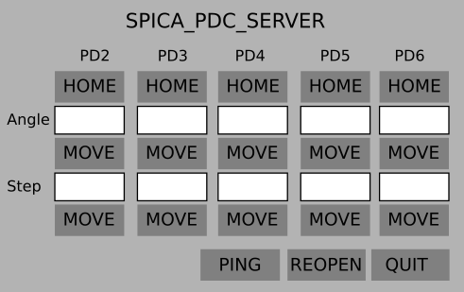
Figure 1: spica_pdc_server GUI

spica_adc_server
This server accepts 36 commands (3 commands per prism and per beam):
- HOME: go back to the home position of the rotation stage
- MOVE angle: go to the angle position
- MOVE step: go to the step position
The layout of the GUI is presented in Figure 3.
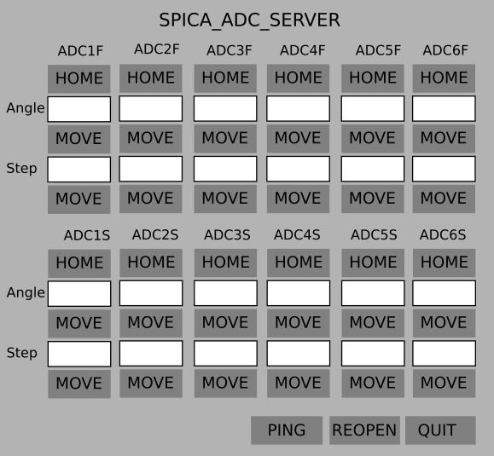 Figure 2: spica_adc_server GUI

spica_periscope_server
This server accepts 2 commands only:
- UP: go to the SPICA position. The light from the telescopes or STS goes to SPICA.
- DOWN: go to the CHARA position. The light from the CHARA source goes towards the telescopes.
The layout of the GUI is presented in Figure 1.
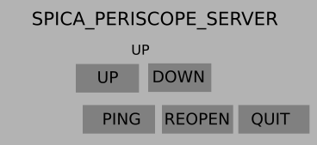
Figure 3: spica_periscope_server GUI

spica_ip-ctrl_server
This server accepts 24 commands, 1 command per axis (24 axes). Each command corresponds to a relative movement:
- MOVE value
The layout of the GUI is presented in Figure 4.
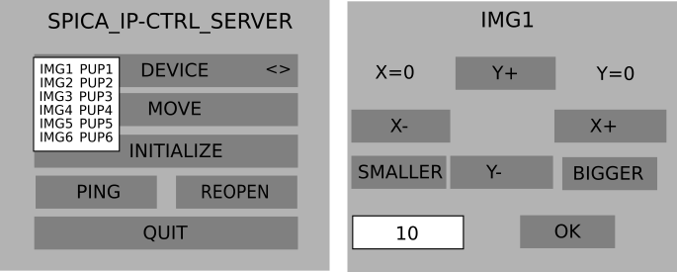
Figure 4: spica_ip-ctrl_server GUI

spica_tt-tracker_server
This server accepts 12 commands, 1 command per axis (12 axes). Each command corresponds to a relative movement:
- MOVE value
The layout of the GUI is presented in Figure 5.
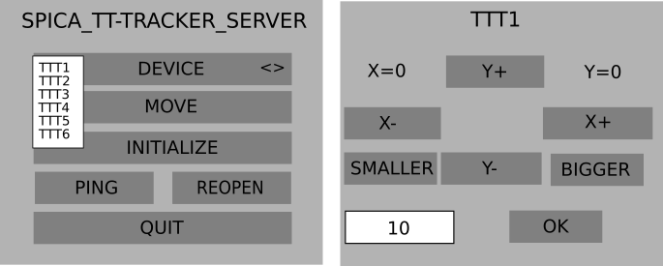
Figure 5:spica_tt-tracker_server GUI

spica_delayline_server
This server accepts 15 commands, 3 commands per axis (5 axes):
- MOVE value: relative movement
- MVABS value: absolute movement
- HOME: go back to home position
The layout of the GUI is presented in Figure 6.
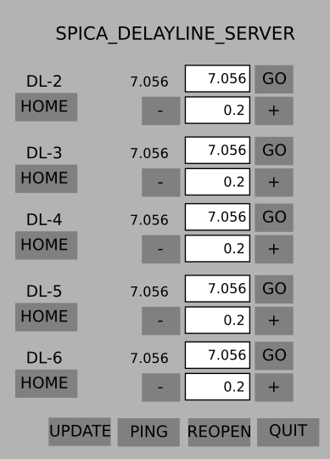
Figure 6: spica_delayline_server GUI

spica_shutter_server
This server accepts 18 commands, 3 commands per shutter (6 axes):
- OPEN
- CLOSE
- STATUS
The layout of the GUI is presented in Figure 7.
Figure 7: spica_shutter_server GUI

spica_grating_server
As the mechanical design of the spectrograph is not started, it is difficult to define exactly this server. Hereafter, we define the minimal high-level commands, but we will certainly add some low-level commands in order to command each motorize axis directly.
This server accepts 3 commands:
- LOW: insert the Low-Resolution dispersive optics
- MEDIUM value: insert the Low-Resolution dispersive optics and select the central wavelength
- HIGH value: insert the High-Resolution dispersive optics and select the central wavelength
The layout of a minimal GUI is presented in Figure 9.
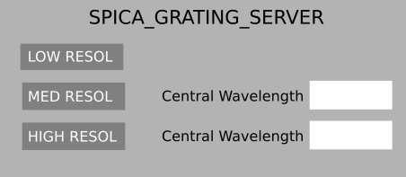
Figure 9: spica_grating_server GUI

Detectors

spica_scidet_server
This server grabs the frame recorded by the science detector and copy them into a shared memory. This shared memory is connected to the scientific RTD and to a process dedicated to save the frames into FITS files. Both processes are described in the document SPICA-VIS-0003 (SPICA-VIS-observingsoftware). In addition, this server accepts commands to configure the detector:
- START: start acquisition
- STOP: stop acquisition
- SHUTTER OPEN: open the internal shutter of the ANDOR detector
- SHUTTER CLOSE: close the internal shutter of the ANDOR detector
- GET DIT: get the current DIT (Detector Integration Time)
- GET SIZE: get the windowing (LOW, MED or HIGH)
- GET TEMP: get the detector temperature
- GET GAIN: get the detector gain
- SET DIT: set the current DIT
- SET SIZE: set the windowing (LOW, MED or HIGH)
- SET TEMP: set the detector temperature
- SET GAIN: set the detector gain
The layout of the GUI is presented in Figure 10. The UPDATE button allows to read and display the current DIT, GAIN, Temperature and Size.
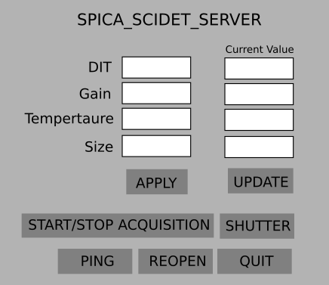
Figure 10: spica_scidet_server GUI

spica_ipdet_server
This server grabs the frame recorded by the Image/Pupil detector and copy them into a shared memory. This shared memory is connected to the Image/Pupil RTD, to a process dedicated to save the frames into FITS files and to a process dedicated to servo the position of the bright speckle on to a reference pixel corresponding to the core of the optical fiber. The 3 processes are described in the document SPICA-VIS-0003 (SPICA-VIS-observingsoftware). In addition, this server accepts commands to configure the detector:
- START: start acquisition
- STOP: stop acquisition
- SHUTTER OPEN: open the internal shutter of the ANDOR detector
- SHUTTER CLOSE: close the internal shutter of the ANDOR detector
- GET DIT: get the current DIT (Detector Integration Time)
- GET SIZE: get the windowing (Full Frame or Fast TipTilt windowing)
- GET TEMP: get the detector temperature
- GET GAIN: get the detector gain
- SET DIT: set the current DIT
- SET SIZE: set the windowing (Full Frame or Fast TipTilt windowing)
- SET TEMP: set the detector temperature
- SET GAIN: set the detector gain
- PUPIL: insert pupil optics
- IMAGE: remove pupil optics

The layout of the GUI is like the one of spica_scidet_server (see Figure 11). One additional button will be inserted in order to insert/remove pupil optics.

Power

spica_power_server
This server accepts 12 commands:
- R ON: Switch on retrofeed source
- R OFF: Switch off retrofeed source
- S ON: Switch on spectral calibration source
- S OFF: Switch off spectral calibration source
- SC ON: Switch on scientific detector
- SC OFF: Switch off scientific detector
- IPC ON: Switch on image pupil detector
- IPC OFF: Switch off image pupil detector
- IT ON: Switch on injection table devices
- IT OFF: Switch on injection table devices
- ST ON: Switch on spectrograph table devices
- ST OFF: Switch on spectrograph table devices

The layout of the GUI is presented in Figure 11. In the future, we could imagine adding new switches for the injection table, one per module (SFO, ADC, PDC, …) for example.
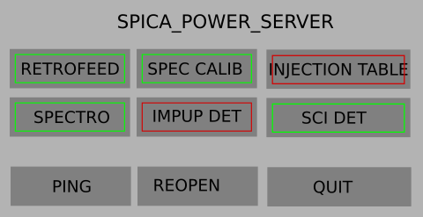
Figure 11: spica_power_server GUI

